Practice questions Additional Airspace Maps - Key

1A. Refer to FAA-CT-8080-2H, Figure 75 area 6. During preflight planning you plan to operate in R-205, where would you find additional info regarding this airspace?
- In the aeronautical information manual
- In the Charts Supplements US
- In the special Use Airspace of the chart.
Answer C

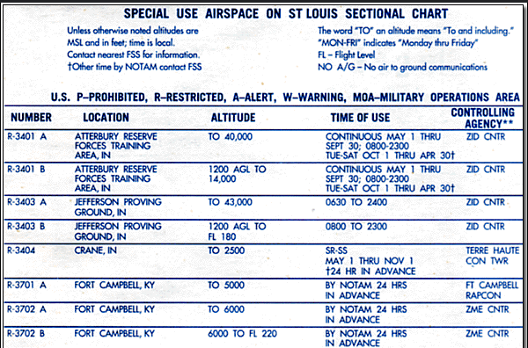

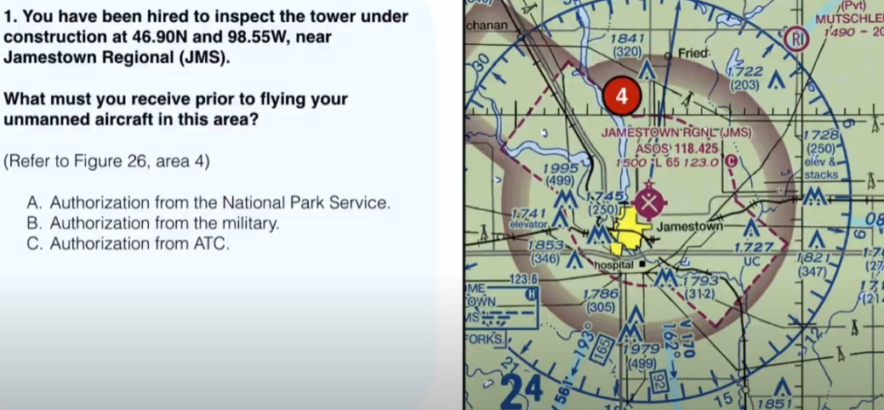Answer C Authorization from ATC
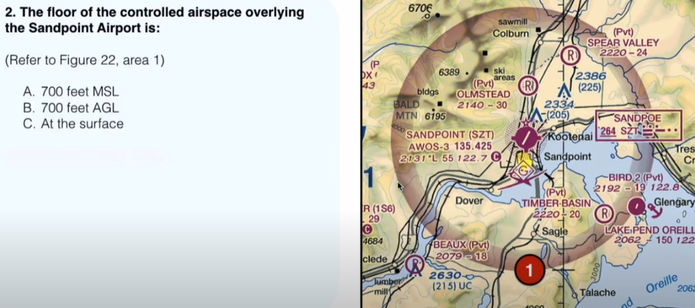B 700 Ft AGL

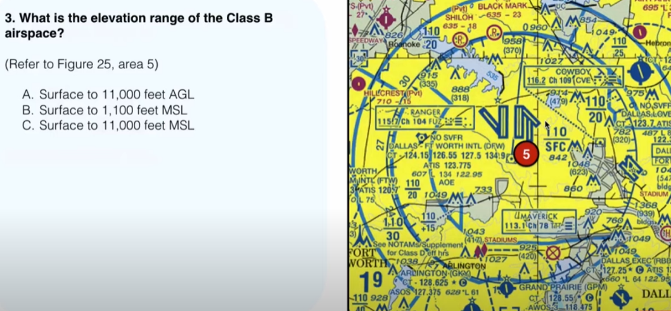C. Surface to 11,000 feet MSL
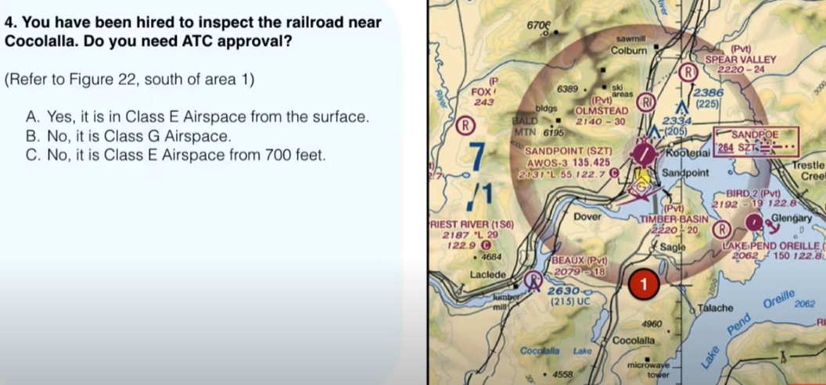 B no its in class G Airspace
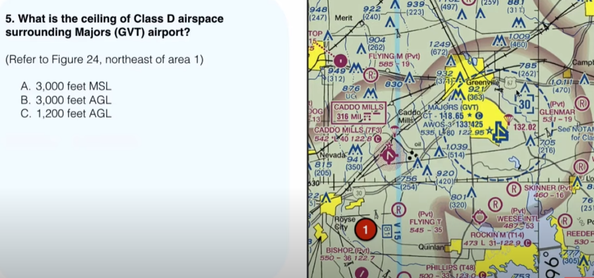A. 3,000 feet MSL
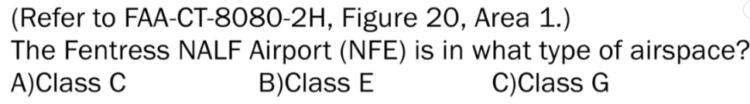
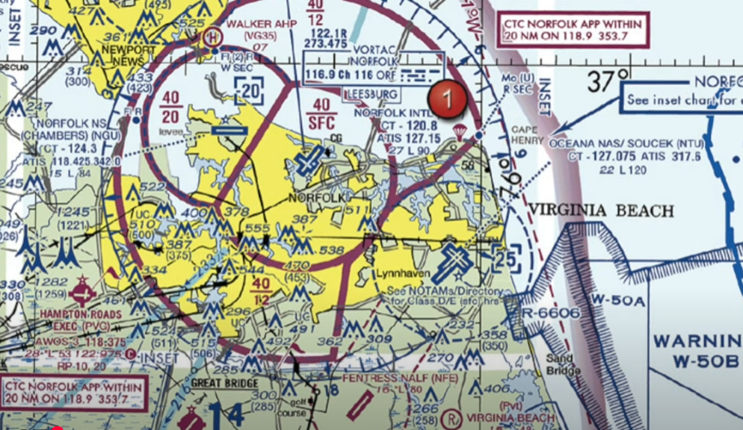 B. Class E sfc airspace

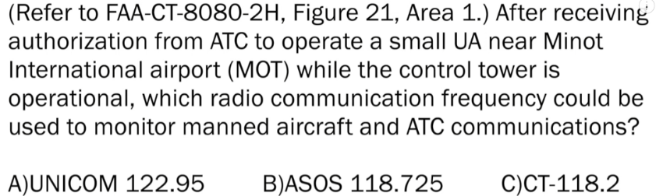

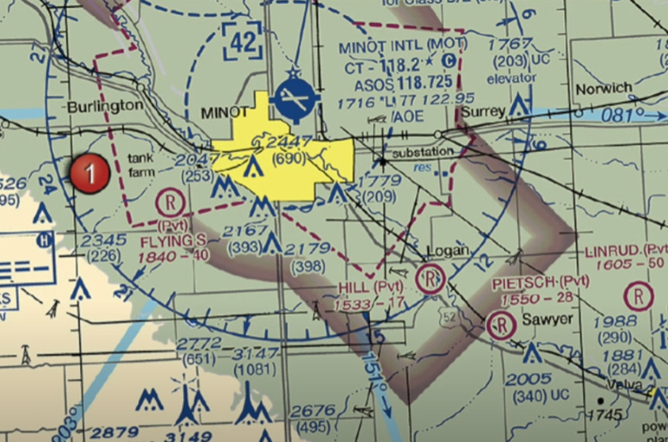

c. 118.2

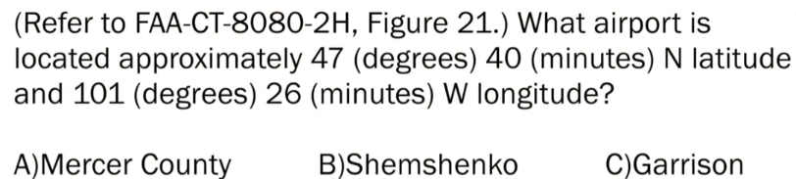
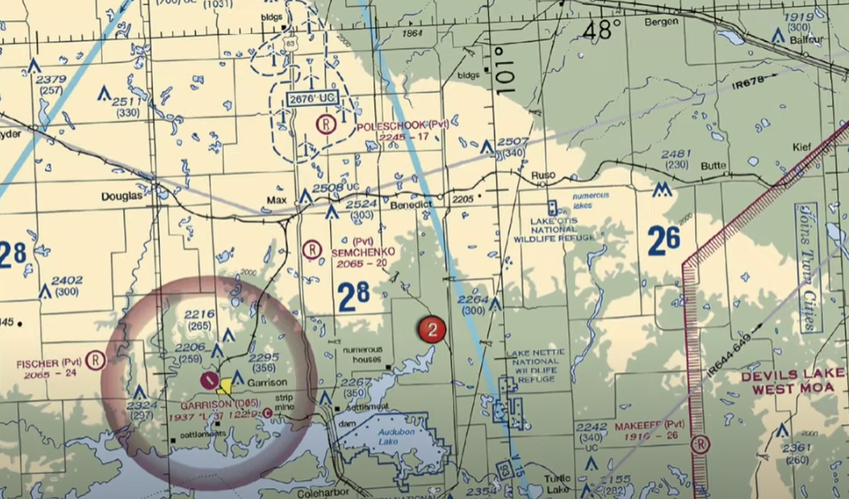
C. Garrison

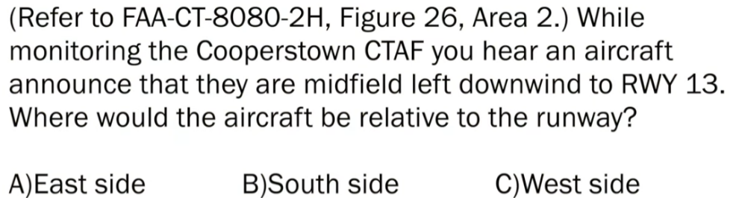

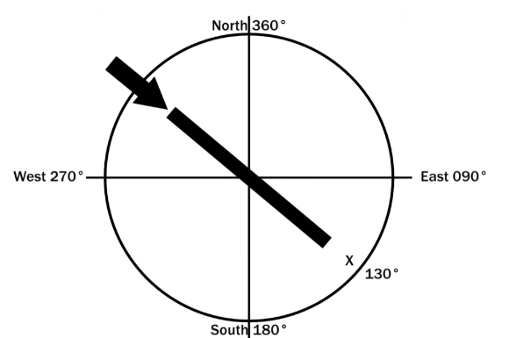
- East side

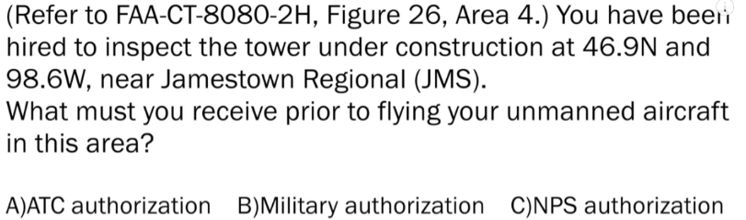
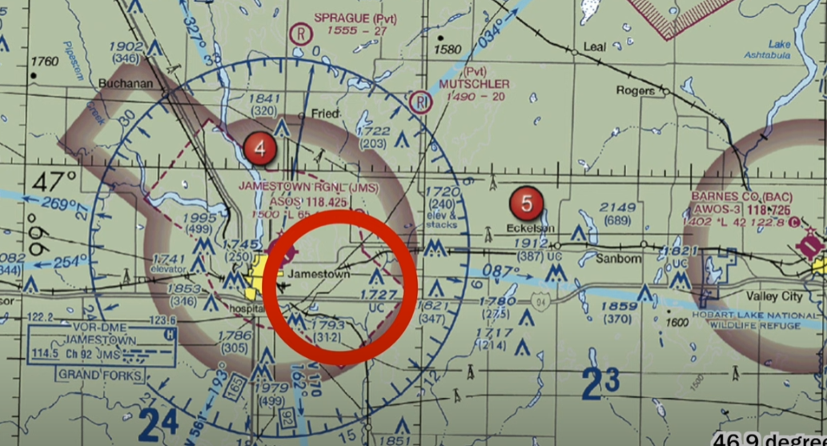

- ATC authorization - because class E airspace requires it

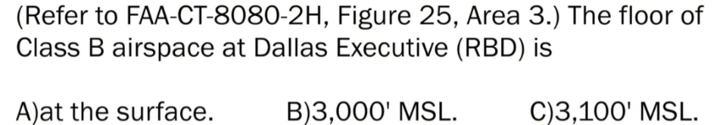
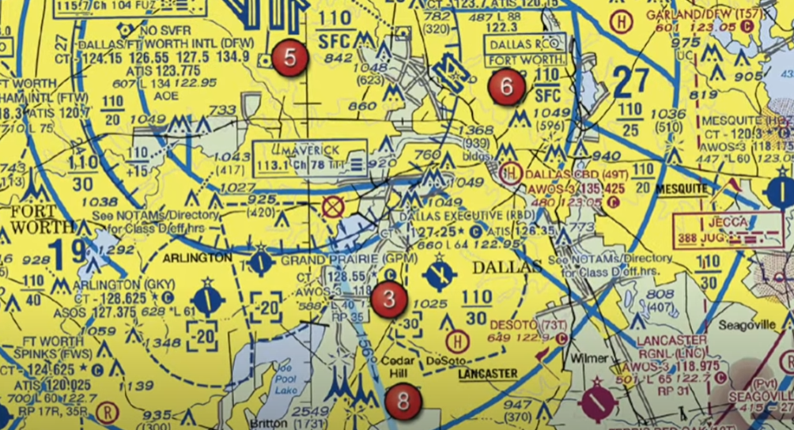

- 3,000 MSL
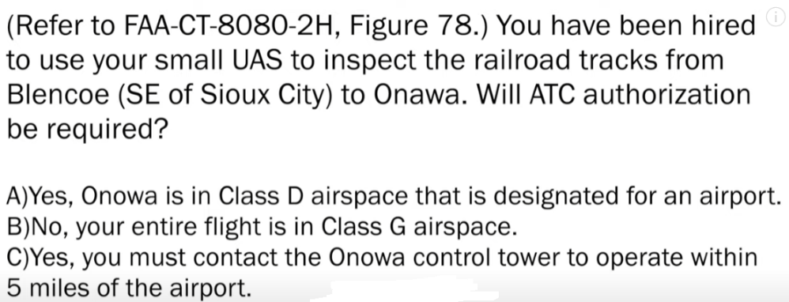

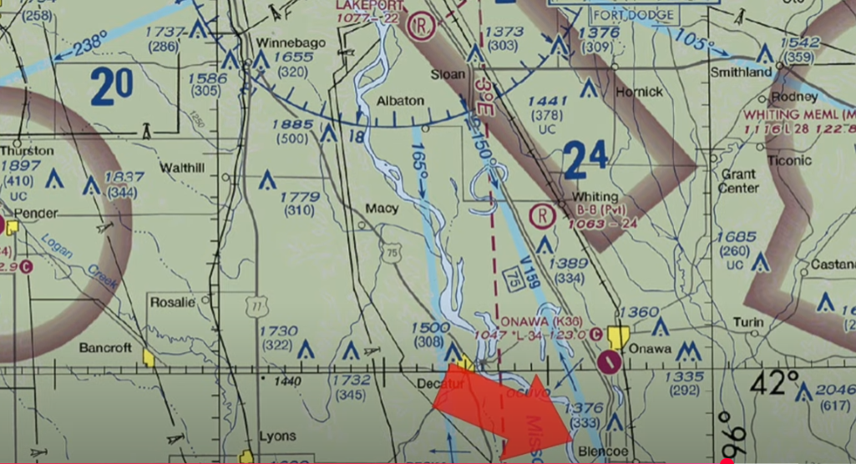

b. No you are in class G because class E airspace doesn’t start until 1200 ft

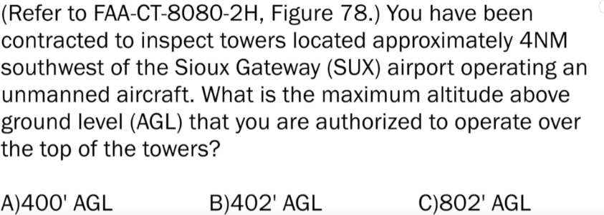
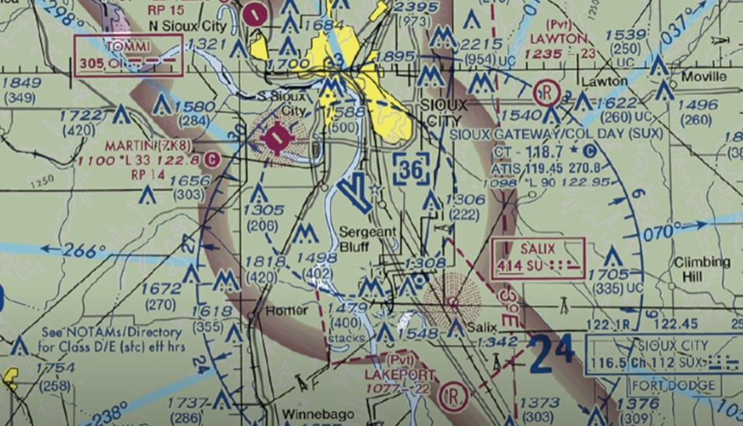 C 802 AGL

